Student Name: __________________

Total Points (80 pts) __________________

**Due: November 21, 2014 before the class**

**Project: Interactive Quiz**

CSCI 5520 Rapid Java Application Development

Armstrong Atlantic State University

This is an individual project. You can share, discuss, and exchange ideas with others. But you have to write your own code.

Develop an interactive quiz using JSF. The quiz is for 43 chapters. The quiz for Chapter x is accessed using a URL like this:

http://tiger.armstrong.edu:8080/YourLastName/faces/Quiz.xhtml?chapter=x

Your quiz should look like this: (You can view this from http://tiger.armstrong.edu/selftest/selftest9e?chapter=1)

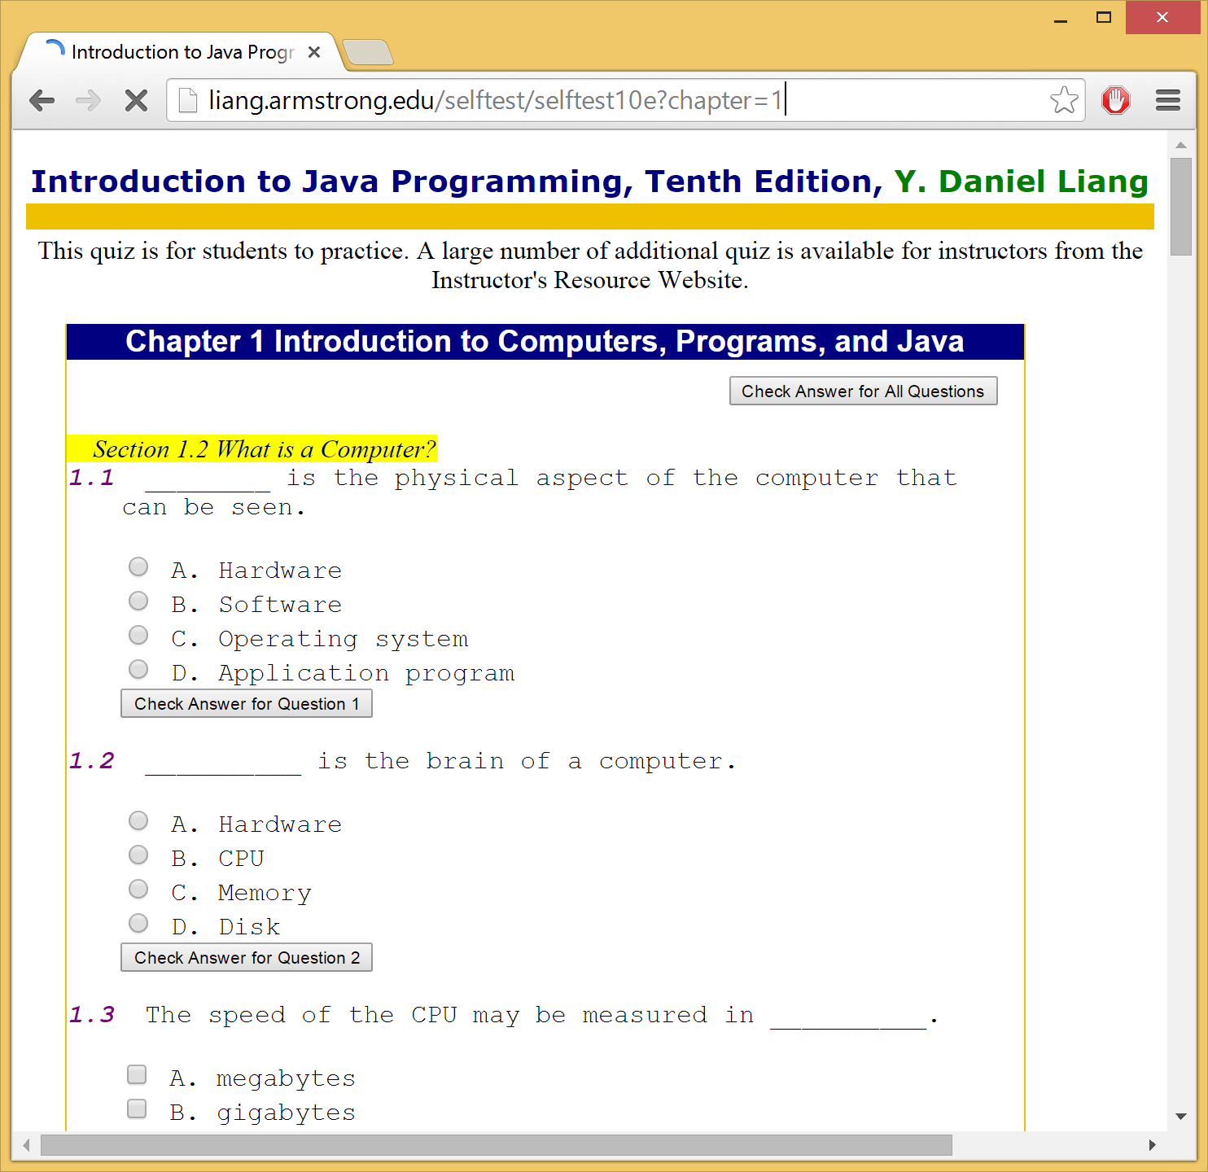

The original quiz data is stored in c:\selftest\selftest10e. They are text files named chapter1.txt, chapter2.txt, etc. The file can be downloaded from [www.cs.armstrong.edu/liang/data/selftest10e.zip](http://www.cs.armstrong.edu/liang/data/selftest10e.zip).

Develop the project using JSF from NetBeans. Name your project YourLastName and the starting .xhtml file as Quiz.

Part I of the project:

Enable the user to take a quiz that works like <http://liang.armstrong.edu/selftest/selftest10e?chapter=1>

Part II of the project:

Require a user login before taking a quiz. When a user opens a quiz such as <http://liang.armstrong.edu:8080/YourLastName/faces/Quiz.xhtml?chapter=x>, your program should check if the user has logged in. If not, present an interface for user login. Pre-create some usernames in your database. One of users is tim with password 123.

Your database name is selftest in MySQL. Your database username/password is scott/tiger. Your table for storing quiz users is User defined as follows:

create table User(username varchar(50) primary key,

firstname varchar(50),

mi char,

lastname varchar(50),

password varchar(50),

whencreated timestamp default current_timestamp);

insert into User (username, password) values ('tim', '123');

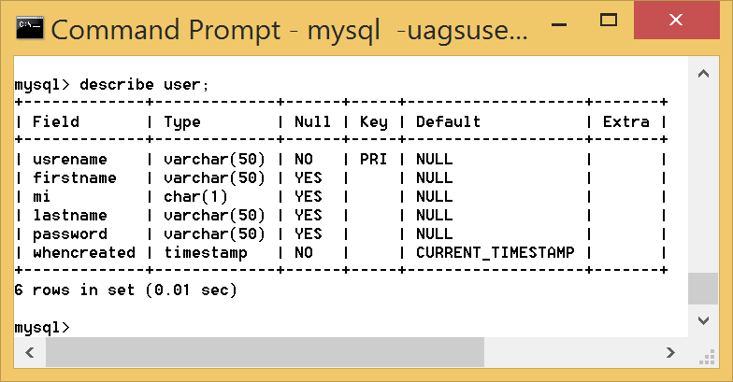

Part III of the project:

Store user quiz submission records into a table named intro10e. The definition of intro10e is as follows:

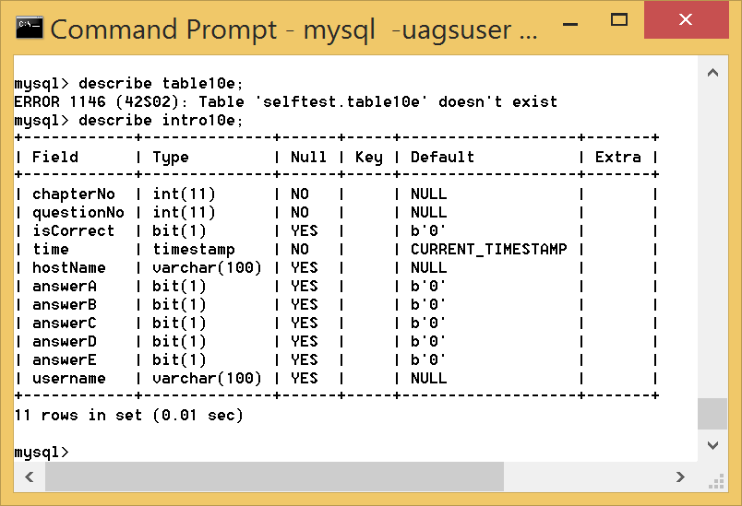

create table intro10e (

chapterNo integer,

questionNo integer,

isCorrect bit default 0,

time timestamp default current_timestamp,

hostname varchar(100),

answerA bit default 0,

answerB bit default 0,

answerC bit default 0,

answerD bit default 0,

answerE bit default 0,

username varchar(100));

For each question submitted, store username, chapterNo, questionNo, isCorrect, time, hostname, and the choices selected (answerA, answerB, answerC, answerD, answerE). Hostname is the user IP address.

What to submit?

A Zip file of your project.

Email me if you have any questions.

Check list for submitting the project:

1. Are your quiz data files stored in c:\selftest\selftest10e? You should have files c:\selftest\selftest10e\chapter1.txt, c:\selftest\selftest10e\chapter2.txt, …, and c:\selftest\selftest10e\chapter43.txt.
2. Is project named YourLastName?
3. Is your database named selftest with uername/password being scott/tiger?
4. Is your table User defined correctly?
5. Is your table intro10e defined correctly?
6. For Part III, you need to store username, chapterNo, questionNo, isCorrect, time, hostname, and the choices selected (answerA, answerB, answerC, answerD, answerE) for each question submitted. Hostname is the user IP address.
7. Zip the complete NetBeans project and test it. Name your project as YourLastName.zip.
8. Have you tested the zip file submitted to me?
9. Submit the zip file to me before 11AM tomorrow morning.